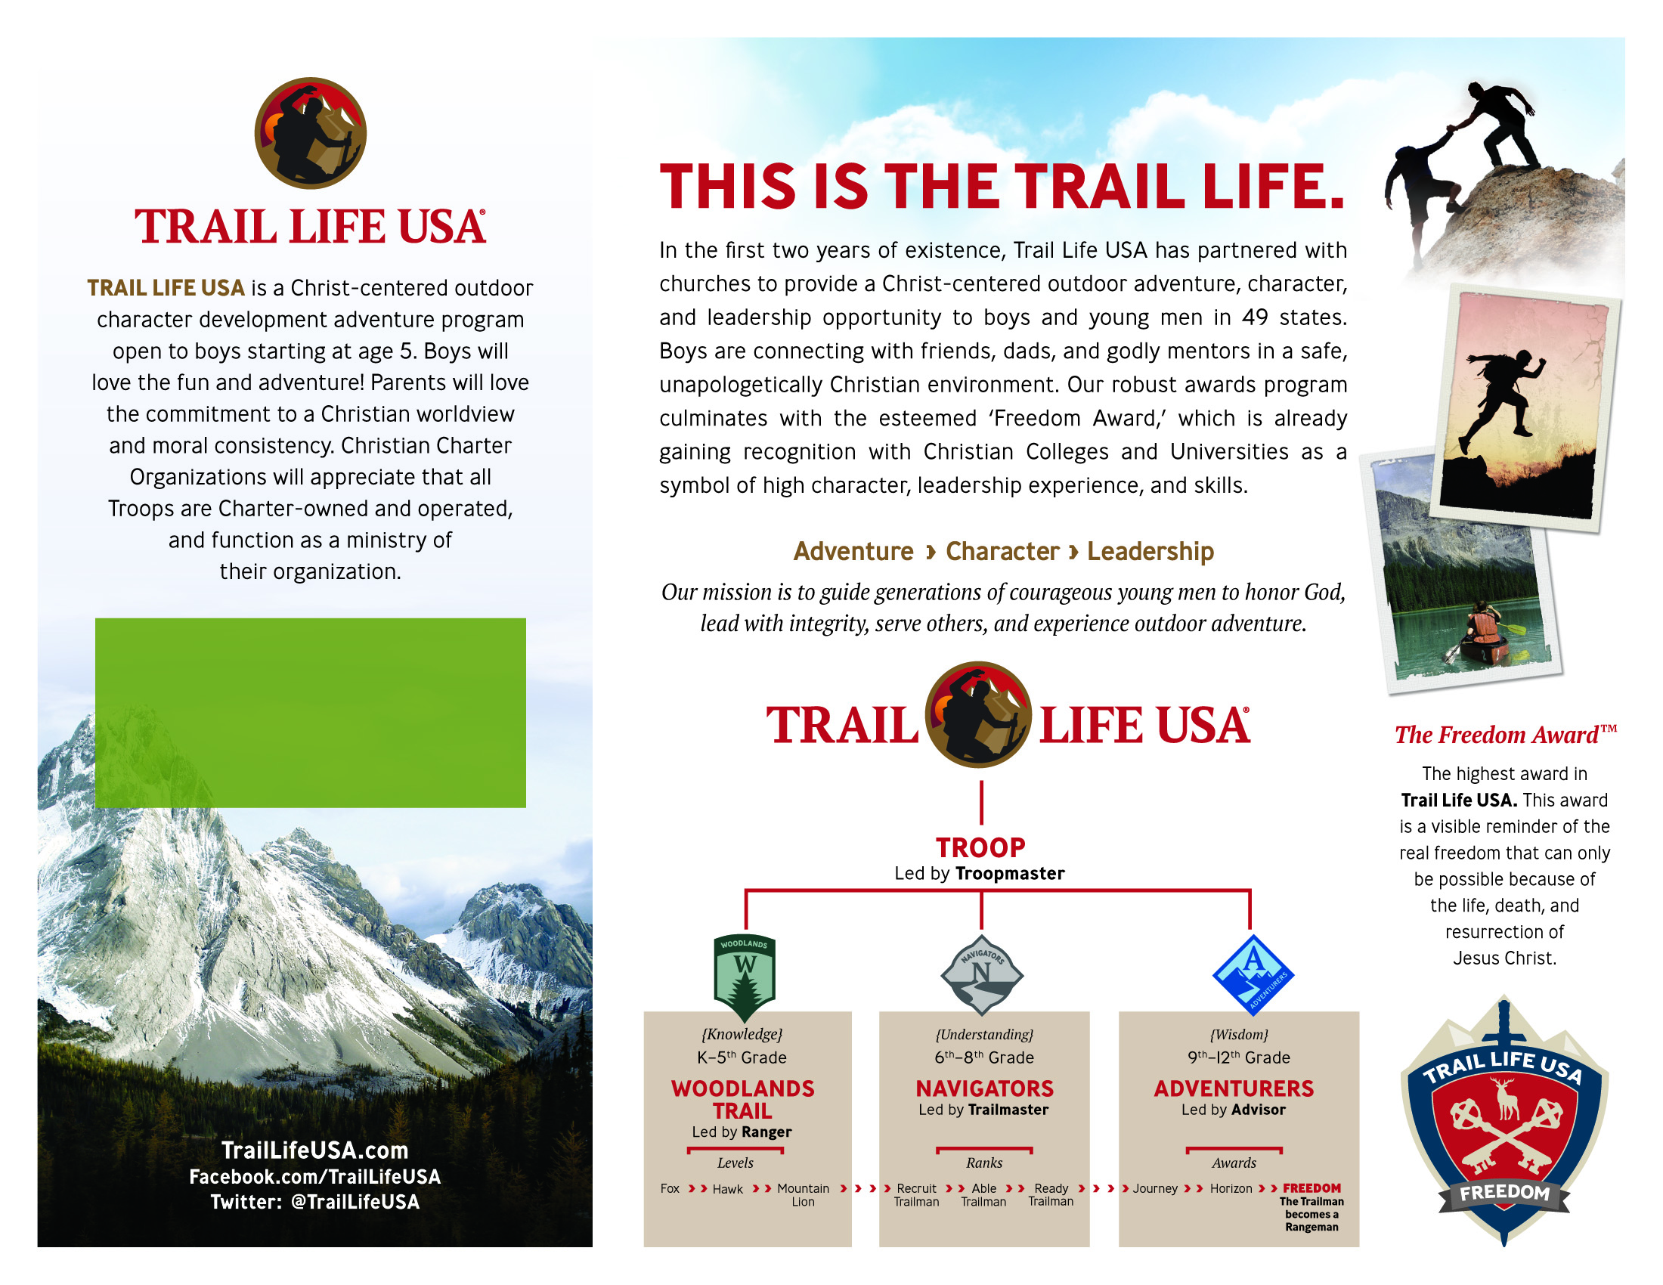

**Troop MI-0110**

**Meeting at Banner of Christ on  
Monday nights from 6:30 to 8pm starting on Sept 13, 2021  
Contact info: TrailLifeMI0110@gmail.com**



*Email* [*ahg@bannerchurch.org*](mailto:ahg@bannerchurch.org)

*for more information on Troop MI1313*